OCEANA COUNTY 4-H SMALL MARKET
POULTRY RECORD BOOK - 2025
(for ages 8 and up)
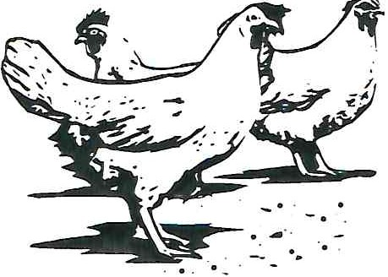
As a member of the Sm a ll Market Animal Project, you are required to sub mi t your records as part of an educational project notebook in order to show your animal at the Oceana County Fair. This notebook must be shown to the Poultry Superintendent or designated Small Market Weighmaster at the time of weigh-in and then entered by you in the Educational Notebook Division at the Oceana County Fair on Entry Day.

AGE: _
The age you enter depends on how old you were on January 1, 2025.

NUMBER OF YEARS IN PROJECT: _

Use this sheet as the first page of your project record book. Fill it out completely.
Please print or type neatly.

NAME _

4-CLUB

LEADER _

DATE RECORDS STARTED _DATE ENDED _

PROJECT BREED VARIETY _

(
C±Ji

JUDGE'S SCORE/COMMENT SHEET

(PLEASE DO NOT REMOVE, PLACE THIS SHEET IN SHEET PROTECTOR OR GLUE TO COVER). This
sheet must be keep free to the judge to write their comments.

This sheet should help each 4-H 'er understand their ribbon placing.

- Specific educational value or worth

_ All questions were answered completely All calculations were correct Calculations were incorrect
_ Questions were not completely answered

_ Questions were not answered (mi sse d questions)

- Notebook contains all project records

_ Notebook contained all project records and were fully completed

_ Notebook contained additional project related information (research materials etc.)

_ Project records were incomplete

_ The re was no additional project related information

- Accuracy, neatness and general appearance

_ No teb o ok was neat in appearance (typed/hand printed)

_ Notebook pages were clean and stain free

_ No te book pages were in order and complete

_ No te b ook pages were out of order and missing pages

_ No te b ook was difficult to read and messy

_ No te b ook had wrinkled and stained pages Other Comments:

OBJECTIVES

  - Develop desirable work habits, sp o rtsm a nsh ip , and ability to coop era te and express ideas through participation in pro jec ts, discussions, method demonstrations, jud gin g teams, and exhibits.
  - Experience the pride and resp o nsibi lity of leasing/ owning and caring for poultry.
  - Lea rn how to feed, fit, sh o w, breed and raise poultry.
  - Le a rn proper handling procedures to prevent injuries to 4-H m e m b ers a nd their poultry projects.
  - Appreciate and use sc i e ntific informa tion in poultry production and marke ting.
  - Im p rove knowledge of grading, marketing and merchandising of poultry and poultry products.
  - Impro ve knowledge of the nutritive value of poultry meat and eggs and how
they c ontrib ut e toward good health.
s. Le a rn the importa nce of the poultry industry to the local, state, and national economies.
- Acquire inform a tion on the opportunit y that poultry offers as a c aree r.

This record book is part of your Sm a ll Market Po ul try p ro ject . By keeping records up­ to-d ate you will be ab le to see how muc h progress you make as you set goals and work to accomplish them. Write or typ e neatly and clearly. Please keep the pages in order. Feel free to add extra pages at the end of your notebook.

SCORING CRITERIA
Th e following breakdown will be used during the jud gi ng process of all market livestoc k notebooks.

A. Sp eci fic ed uc a tiona l va lue or worth | 30%
B. Crea tive way of showing what has been learned | 10%
C. Noteb ooks c o nta ins a ll project rec ord s | 50%
D. Accuracy, neatness and general appearance | 10%

POULTRY PROJECT INSTRUCTION SHEET FOR ALL POULTRY PROJECTS

  - Use a binder to keep all of your records in one place. Start your record book the day you receive your poultry.
  - Add weekly progress notes to your record book. Take pictures at the start, during and end of your project. Put these in your record book.
  - Keep all project receipts for feed, equipment, veterinary, housing costs. Include a copy of your project purchase record. Include any documentation of birth/hatch by a breeder or hatchery. Attend clinics, do research online, read books about poultry.

COMPLETING THIS RECORD BOOK HELSP YOU:

  - Set goals and accomplish them.

  - Help you to understand your project cost, profit or loss. Remember a loss does not mean that you have failed!

  - We all have "losses" at one time or another use it as a tool to improve.

  - Will help you understand what you learned by doing this project.

  - A good keepsake... it will be nice to look back on when you are older.

JOURNAL OF CARE
The SMAA Committee would like the judge to see the time and effort which you put into the care & management of your project.
Incl ud e th e following:
Feeding and watering practices
Health practices and medicines (vaccinations, etc.)
General Management (building a cage, cleaning living area, feed pans, etc.)

DAILY- Things done once or twice a day
WEEKLY - Things done once or twice a week
MONTHLY- Things done once a month
YEARLY - Things done one time or occasionally throughout the year

2025- SM A PO ULTRY PAGE S

Describe the type of POULTRY being used in this project. List breed and variety. Why did you choose this breed?

WEIGHT CHART

Date | Age | Weight

FINAL WEIGHT (FW)

_ AGE

_ DATE_ _ _ _

EXPENSES

(A) Cost of chicks $ _

DATE | LBS. OF FEED | FEED VARIETY | COST
 |  |  | $
(B) |  | TOTAL SPENT ON FEED | $

DATE | OTHER EXPENSES, VET, SUPPLIES, HOUSING, ETC. | COST
 |  | s
(C) | TOTAL SPENT ON OTHER EXPENSES | $

GRAND TOTAL OF ALL EXPENSES (TE):
(total of A+B+C)
$ _

=
Total Expenses (TE) Final Weight (FW) Break Even Price (BE)
(total cost per pound to raise your animal)

**The breakeven price is the price that you need to get at the
Small Market animal auction in order to not lose money on your market project **

MARKET POULTRY

Tu rkey s 2/Pen Duck 2/Pen _ _ _ Geese 2/Pen

Market Meet Chickens 3/ Pe n

What breed of bird did you order? Why did you ord er this breed? _

Wh e re did you order your birds from? _ How many birds d id you o rd er for your market project? _ How much did each bird cost? - - - - - -
MARKET PROJECT FEED AND CARE

What typ e of quality fee d did you use at the START of your project? Percentage of protein?

What type of quality fe ed did you use at the FINISH o f your pro je ct ? Pe rc e nta ge of protein?

Why is PROTEIN important? _

List so m e other importa nt ingredients that are found in poultry fe e d.

Did you fee d / g iv e any type of FEED SUPPLEMENTS to your marke t projects? If so, exp la in.

How often did you fee d your project daily? Did your project have clean water daily? _ Wh e re did you rai se your market project? Barn? Coop? _ Ho w did you p rotect your project from dangerous animals? _ _ _ _ _ _ _ _ _

How did you ke ep your pro je ct hea lthy from disease, like lic e or mites?

(Those completing a Chicken Project complete this page)

Parts of a Chicken (Cockerel)

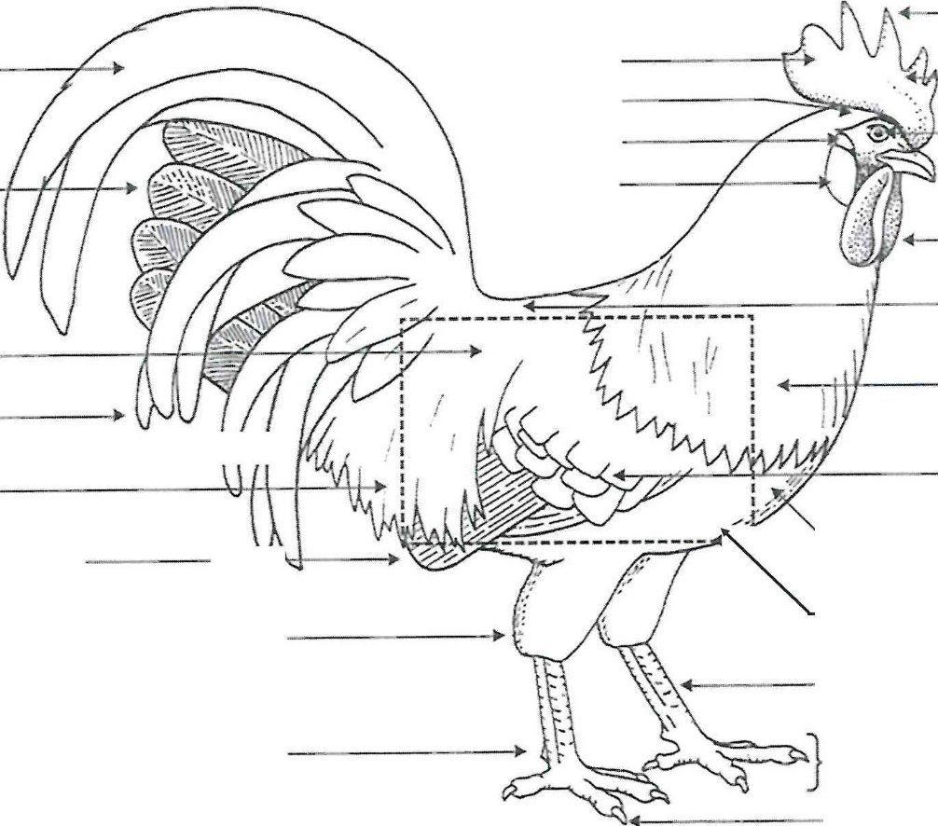
Dotted Box



tt1 •ll)§iii1
UA Q UBOIIATORY KIT

A | Base | B | Beak | C | Blade | D | Body
E | Bre ast | F | Claw | G | Comb | H | Ea r
I | Ear Lob e | J | Eye | K | Flu ff | L | Foot
M | Hackle | N | Hock | 0 | Lesser Sickles | p | Main Tail
Q | Prim ary Flight Fea t h - er | R | Poin t | s | Saddle Fe a th e rs | T | Shank
u | Sic kles | V | Spur | w | Wattles | X | Win g Bow

(Those completing a Duck Project complete this page)

Parts of a Duck
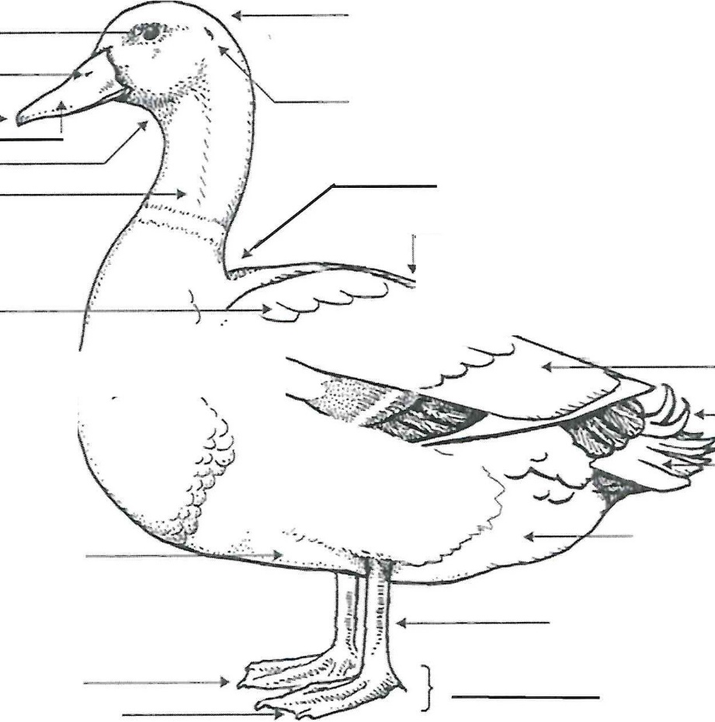
- - -
) ,
)
.,.



LEARJll(Q LABORATORY KfT
Et1 •!•lfoi1

A | Bean | B | Bill | C | Breast | D | Cape
E | Drake Feathers | F | Ear | G | Eye | H | Fluff
I | Foot | J | Head | K | Keel | L | Neck
M | Nostril | N | Primaries | 0 | Saddle | p | Secondaries
Q | Shank | R | Tail | s | Toe | T | Throat
u | Web | V | Wing Bow

(Those completing a Turkey Project complete this page)
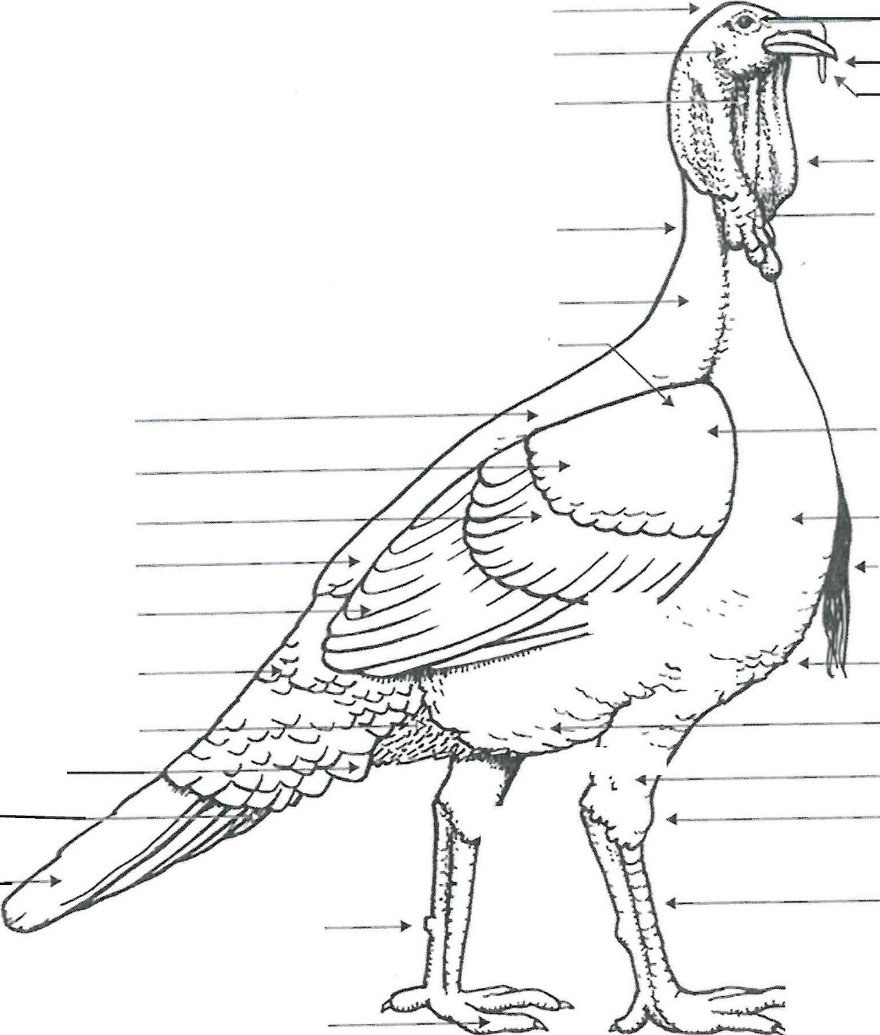

A | Appendage(Snood) | B | Back | C | Beard | D | Breast
E | Cape | F | Caruncles | G | Ear | H | Eye
I | Fluff | J | Foot | K | Head | L | Hock
M | Keel | N | Leg | 0 | Neck | p | Saddle
Q | Secondari es | R | Shank | s | Sh oulder | T | Skirt s
u | Spu r | V | Under Tail Coverts | w | Wattle | X | Wing Bar
y | Wing Bow | z | Wing Front

(Those completing a Goose Project complete this page)

Parts of a Goose

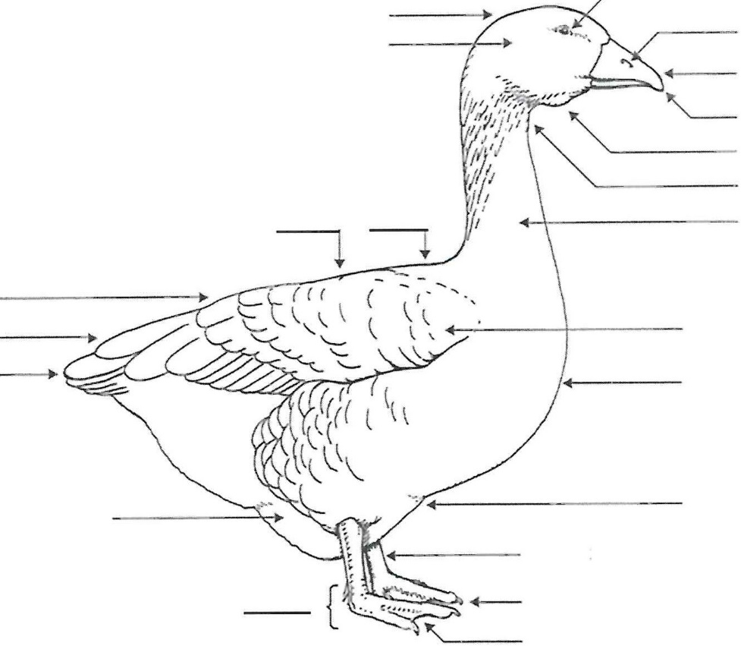



l.LWilNO W DllATORY IUT
t-i,i•!•lfoti

A | Bean | B | Bill | C | Breast | D | Cape
E | Dewlap | F | Ear | G | Eye | H | Fluff
I | Foot | J | Head | K | Keel | L | Neck
M | Nostril | N | Primaries | 0 | Saddle | p | Secondaries
Q | Shank | R | Throat | s | Toe | T | Tail Feather
u | Web | V | Wing

PROJECT PROGRESS AND MANAGEMENT REPORT

- What part of your project did you enjoy the most?

- What was the hardest part of your project? _

- Would you recommend the breed that you chose for a market project? _

Why or why not? _

I pledge ...

. The 4-H Pledge
(fill in the blanks)

My to clearer thinking, My to greater loyalty, My to larger service, and My to better living,
For My My ,

My _, and My

The 4-H MOTTO: _

POTENTIAL BUYERS NAMES

As part of your 4-H Market Livestock Project, you must personally contact at least five potential buyers before the Oceana County Fair. You are encouraged to seek two new buyers that have not been asked or submitted before. You also must have at least three different buyers than those of your siblings in the market livestock project. Please confirm with your buyers their accurate mailing address (example: post office box vs. a street address). The information on page 14 must be completed and taken to the Oceana County MSU Extension Office on or before the due date where it will be copied and used to send out letters to your potential buyers. This page will remain in your notebooks. This is a Market Livestock Committee rule. Failure to comply will result in not being able to sell your animal in the 4-H Market Livestock Sale. Please have all buyers signatures on (1) one sheet as copies need to be made at the MSUE office.

Page14
2025- SM A Poultry
Da te : _ Sta ff: _

SMALL MARKET POTENTIAL BUYER'S LIST POULTRY PROJECT {AGES 8 & up)

Name Club
PIease print business names and complete addresses clearly.

- Contact Name Business Name - - - - - - - - - - - - - - - - - - - - - - -
MaiIing Address _ _ _ _ _ _ _ _ _ _ _ City Zip_ _
Phone After Hours Phone- - - - - - - - - -
Mailing Preference (Please Check One): Email Postal Delivery

Email - - - - - - - - - - - - - - - - - - - - - - - - - -
Signature_ _ _ _ _ _ _ _ _ _ _ _ _ _ _ _ _ _ _ _ _ _ _ _ _ _

- Contact Name Business Name - - - - - - - - - - - - - - - - - - - - - - -
MaiIing Address _ _ _ _ _ _ _ _ _ _ _ City Zip
Phone After Hours Phone- - - - - - - - - -
Mailing Preference (Please Check One): Email Postal Delivery

Email - - - - - - - - - - - - - - - - - - - - - - - - - -
Signature_ _ _ _ _ _ _ _ _ _ _ _ _ _ _ _ _ _ _ _ _ _ _ _ _

- Contact Name Business Name - - - - - - - - - - - - - - - - - - - - - - -
MaiIing Address _ _ _ _ _ _ _ _ _ _ _ City Zip
Phone After Hours Phone- - - - - - - - - -
Mailing Preference (Please Check One): Email Postal Delivery

Email Signature_ _ _ _ _ _ _ _ _ _ _ _ _ _ _ _ _ _ _ _ _ _ _ _ _ _
(Must be stamped by the MSU Extension Office)

2025- SMA POULTRY PAGE 16

PICTURES OF YOUR PROJECT
(Plea se use this page for your project pictures. Add additional pages if you would like. The judges appreciate you labeling the pictures so they know what the picture shows.)

NON-CLUB POINTS
4-H SMALL MARKET ANIMAL ASSOCIATION/JUNIOR MARKET PROJECT ATTENDANCE RECORD
(must be filled out by participant before requesting signatures from the office)
MEETING NAME | LOCATION | DATE | POINTS | SIGNATURE OF LEADER, SUPERINTENDENT OR MSU STAFF
Please note: This form must be included with your notebook and turned into the weigh master on entry day of the Fair. BEFORE SEEKING SIGNATURES AT MSU EXTENSION -MEETING NAME AND DATE MUST BE C OMPLETED. You need to accumulate nine (9) points to be allowed to sell your anima l. Six (6) of these nine (9) points must come from club meetings. Two (2) of these 9 p oints are non-club points must be earned from attending various 4-H events and act ivities. One (1) of these 9 points must be a fairgrounds workbee point. See your leader, the MSUE office, or online at http s: / /ww w .c a nr.msu .e d u/ oc eana / oc ea na county 4 h/ oc ea na 4 h market livestock for a listing of approved nonclub points.

CLUB POINTS
4-H SMALL MARKET ANIMAL ASSOCIATION/JUNIOR MARKET PROJECT ATTENDANCE RECORD

MEETING NAME | LOCATION | DATE | POINTS | SIGNATURE OF LEADER
Please note: This form must be included with your record notebook and turned into the weigh master on entry day of the Fair. BEFOR E SEEKING SIGNATURES AT MSU EXTENSION - MEETING NAME AND DATE MUST BE COMPLETED. You need to accumulate nine (9) points to be allowed to sell your animal. Six ( 6) of these nine (9) points must come from club meetings. Two (2) of the 9 points are non-club points and must be earned from attending various 4-H events and activities. One ( l) of the 9 points must be a fairgrounds workbee point.

